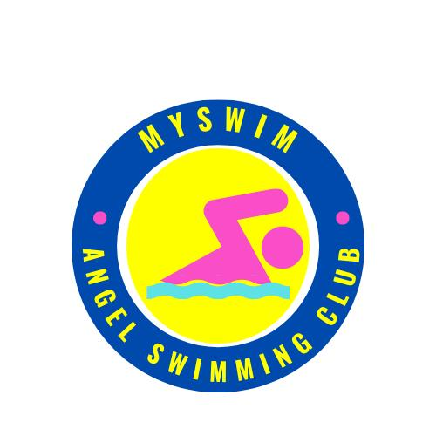

MY SWIM TEAM
NOVICE SWIMMING COMPETITION

- HOSTED BY: MY SWIM TEAM
- SUPPORTED BY: SOLID SWIMMING COACHES OF THE PHILIPPHINES INC.
- DATE: MAY 23, 2026
- VENUE: Philippine Columbian Association
- FACILITIES: a) 25 Meter Pool / 6 Lanes
b) Clean Shower Room
- TIME: Warm-up: 6:00 am - 7:15 am
- Coaches’ Meeting: 7:20 am - 7:45 am
- Start of Meet: 8:00 am
- AGE CATEGORY: AGE BAND (BOYS/GIRLS)
- CLASS ABCD: 6 & under 7,8, 9,10,11,12,13,14,15,16,17 & 0ver
- TECHNICAL RULES: WORLD AQUATIC Rules.
REGISTRATION
- Open to all club’s team and school team regardless of affiliations.
- Entry fee 1,500 pesos.
- Deadline for submission of entries is until MAY 20, 2026
- Verifiable time should be submitted for NOVICE Category.
- Maximum entry of 5 Individual Event + 2 Relay is allowed per swimmer.
- Swimmers for ABC category with no seed time submitted will be declared NT and be place at the early heat.
- All entry should be submitted using official entry form with swimmer’s name, birthday, event number, seed time and duly signed by the coaches, (printed legibly)

AGE OF RECKONING
- Age as of the date of competition MAY 20, 2026
- Coaches must make sure all ages entered are true and correct, it is the team coaches’ responsibilities to check the correctness of their swimmer’s birth date and ages.
RULES:
- Timed final.
- meet rules shall apply according to W.A. rules.
- Verification of swimmer’s age.
- STRICKLY NO DECK CARD ENTRY.
- The technical committee may ask the team to produce birth certificate.
In case the date of registration on birth certificate is more than one (1) year after the date of birth swimmers must submit the following additional documents mentions below. (Certification of true age from organizer’s appointed dentist or physician or whichever body the organizer to decides and appoint at the time the certification may be needed)

WITHDRAWALS
- Withdrawals of entered names & events can be done until FRIDAY.
MAY 20, 2026.
- An administrative fee of P100.00 will be levied for every withdrawal made after the deadline by a coach, on behalf of any swimmer and for any event.
- The administrative fee will only be waived if the swimmer produces a valid medical certificate, but the registration fee will not be refunded.
- The swimmer will not be permitted to participate in any further races for the day.

NOTE:
- The organizer is not responsible for expenses incurred from acquiring said documents. Expenses to be shouldered by the parents/club of the said swimmer.
- Protest/s must be in writing along with a protest fee of Php 2,000. Protests must be filed within 30 minutes after posting of the results. If found valid, the fee will be returned by the protest committee. Any protest filed beyond the said time frame will not be entertained. Only the head coach / team manager may file the protest. The technical jury will be composed of five (5) members.
- Please be mindful for your personal belongings, the organizer is not responsible for any lost
AWARDS:
- Individual: Gold, Silver, and Bronze Medal for the top (3) three finisher of each event per Category ( AGE BAND).
- Trophies will be awarded for the Most Outstanding Swimmers in each Age band based on Standard Points.
- Team Overall: Trophies shall be awarded to the Over-All Champion, the 1st Runner up and 2nd Runner-up (Based on the combined Standard Points for boys’ and girls’ events.
- In case of tie, the number of medals starting with the gold, silver and bronze will be considered.

POINTS SYSTEM:
- Individuals (1st -9), (2nd -7), (3rd -6), (4th -5), (5th -4) (6 th -3), (7 th -2), (8 th -1)
- Relays (1st -18), (2nd -14), (3rd -12), (4th -10), (5th -8) (6 th -6), (7 th -4), (8 th -2)

ENTRIES:
- Use official meet entry form. Birth dates must be indicated in the entry forms.
- No swim-up in individual events
- Faxed entries are not allowed.
- Entries must be duly signed by the teams’ respective coaches.

E-MAIL ENTRIES TO:
EMER MATIENZO | 09054140726 | emermatienzo@yahoo.com
ENTRIES FEES TO:
COACH ZIG CAMUA | GCASH | 09399101865
STRICKLY PROHIBITED:
SMOKING AND ALCOHOLIC DRINKS IS NOT ALLOWED IN THE COMPETITION VENUE.
FOOD STALL ARE AVAILABLE IN THE VENUE
MY SWIM TEAM
NOVICE SWIMMING COMPETITION

OFFICIAL ENTRY FORM

TEAM:
CONTACT #:
COACH:
EMAIL ADD:

Name of Swimmer | Date of | Age | Gender | Event | Seed
(Last Name First) | Birth | Group |  | No. | Time

MY SWIM TEAM
NOVICE SWIMMING COMPETITION

Event No | Age Group | Distance | Stroke | Event No.
BOYS |  |  |  | GIRLS
NOVICE EVENT
101 | 4 YEARS OLD UNDER | 25 METERS | NOODLE RACE | 102
103 | 4 YEARS OLD UNDER | 25 METERS | BACK FLOATER RACE | 104
105 | 4 YEARS OLD UNDER | 25 METERS | DOG PADDLE W/FINS | 106
108 | 5 YEARS OLD OVER | 25 METERS | FREESYTLE KICK | 108
109 | 5 YEARS OLD OVER | 25 METERS | FREESTYLE | 110
111 | 5 YEARS OLD OVER | 25 METERS | BACKSTROKE | 112
113 | 5 YEARS OLD OVER | 25 METERS | BREASTSTROKE | 114
115 | 5 YEARS OLD OVER | 25 METERS | BUTTERFLY | 116
117 | 5-7 YEARS OLD | 4x25 METERS | FREESTYLE RELAY | 118
119 | 8-11 YEARS OLD | 4x25 METERS | FREESTYLE RELAY | 120
ABC EVENT
121 | 12 AND OVER | 4x25 METERS | FREESTYLE RELAY | 122
123 | 7 YEARS OLD OVER | 100 METERS | FREESTYLE | 124
125 | 7YEARS OLD OVER | 50 METERS | BUTEERFLY | 126
127 | 7 YEARS OLD OVER | 50 METERS | BACKSTROKE | 128
129 | 7 YEARS OLD OVER | 50 METERS | BREASTSTROKE | 130
131 | 7 YEARS OLD OVER | 50 METERS | FREESTYLE | 132
133 | 7 YEARS OLD OVER | 4x25 METERS | INDIVIDUAL MEDLEY | 134
 |  | END OF GAME

