FROM ZERO TO HERO

INFORMATION KIT

MACUHA SWIM CHAMPS CUP:
3RD SERIES


FEBRUARY 28, 2026, SATURDAY

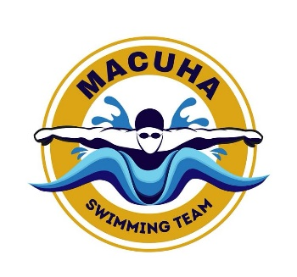
3rd MACUHA SWIMMING CHAMPIONSHIP
CLASS A B C D / AGE GROUP

- HOSTED BY: MACUHA SWIM SCHOOL
- PRESENTED BY: SOLID SWIMMING COACHES OF THE PHILIPPINES INC.
- DATE: FEBRUARY 28, 2026
- VENUE: AMORANTO SPORTS COMPLEX
- FACILITIES: a) 50 Meter Pool / 10 Lanes
b) Clean Shower Room

- TIME: Warm-up: 6:00 am - 7:15 am
- Coaches’ Meeting: 7:20 am - 7:45 am
- Start of Meet: 8:00 am
- AGE CATEGORY: AGE GROUP (BOYS/GIRLS)
- CLASS ABC: Age Group 7-8, 9-10, 11-12, 13-14, 15-16, 17 & 0ver
- CLASS D: 6 & under 7-8, 9-10, 11-12, 13-14, 15-16, 17 & 0ver
- TECHNICAL RULES: WORLD AQUATIC Rules.
REGISTRATION
- Open to all club’s team and school team regardless of affiliations.
- Entry fee 1,500 pesos.
- Deadline for submission of entries is until FEB. 27, 2026
- Verifiable time should be submitted for ABC Category.
- Maximum entry of 5 Individual Event + 2 Relay is allowed per swimmer.
- The Technical Officials and the organizer will not be accepting VIDEO CLIPS as proof of evidence.
- Swimmers for ABC category with no seed time submitted will be declared NT and be place at the early heat.
- All entry should be submitted using official entry form with swimmer’s name, Birthday, event number, seed time and duly signed by the coaches, (printed legibly)

AGE OF RECKONING
- Age as of the date of competition FEBRUARY 28, 2026
- Coaches must make sure all ages entered are true and correct, it is the team coaches’ responsibilities to check the correctness of their swimmer’s birth date and ages.
RULES:
- Timed final.
- Meet rules shall apply according to W.A. rules.
- Verification of swimmer’s age.
- STRICKLY NO DECK CARD ENTRY.
- The technical committee may ask the team to produce birth certificate.
In case the date of registration on birth certificate is more than one (1) year after the date of birth swimmers must submit the following additional documents mentions below. (Certification of true age from organizer’s appointed dentist or physician or whichever body the organizer to decides and appoint at the time the certification may be needed)

WITHDRAWALS
- Withdrawals of entered names & events can be done until FRIDAY, FEBRUARY 20, 2026.
- An administrative fee of P100.00 will be levied for every withdrawal made after the deadline by a coach, on behalf of any swimmer and for any event.
- The administrative fee will only be waived if the swimmer produces a valid medical certificate, but the registration fee will not be refunded.
- The swimmer will not be permitted to participate in any further races for the day.
NOTE:
- The organizer is not responsible for expenses incurred from acquiring said documents. Expenses to be shouldered by the parents/club of the said swimmer.
- Protest/s must be in writing along with a protest fee of Php 2,000. Protests must be filed within 30 minutes after posting of the results. If found valid, the fee will be returned by the protest committee. Any protest filed beyond the said time frame will not be entertained. Only the head coach / team manager may file the protest. The technical jury will be composed of five (5) members.
- Please be mindful for your personal belongings, the organizer is not responsible for any lost.

AWARDS:
- Individual: Gold, Silver, and Bronze Medal for the top (3) three finisher of each event per Category (AGE BAND).
- Trophies will be awarded for the Most Outstanding Swimmers in each age group based on Standard Points.
- Team Overall: Trophies shall be awarded to the Over-All Champion, the 1st Runner up and 2nd Runner-up (Based on the combined Standard Points for boys’ and girls’ events.
- In case of tie, the number of medals starting with the gold, silver and bronze will be considered.

POINTS SYSTEM:
- Individuals (1st -9), (2nd -7), (3rd -6), (4th -5), (5th -4) (6 th -3), (7 th -2), (8 th -1)
- Relays (1st -18), (2nd -14), (3rd -12), (4th -10), (5th -8) (6 th -6), (7 th -4), (8 th -2)

ENTRIES:
- Use official meet entry form. Birth dates must be indicated in the entry forms.
- No swim-up in individual events
- Faxed entries are not allowed.
- Entries must be duly signed by the teams’ respective coaches.

E-MAIL ENTRIES TO:
EMER MATIENZO | 09054140726 | emermatienzo@yahoo.com

STRICKLY PROHIBITED:
SMOKING AND ALCOHOLIC DRINKS IS NOT ALLOWED IN THE COMPETITION VENUE.
FOOD STALL ARE AVAILABLE IN THE VENUE.

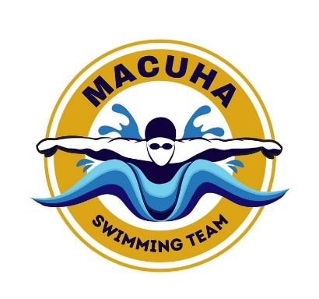

3rd MACUHA SWIMMING CHAMPIONSHIP
CLASS A B C D / AGE GROUP

OFFICIAL ENTRY FORM
TEAM:
CONTACT #:
COACH:
EMAIL ADD:
Name of Swimmer | Date of | Age | Gender | Event | Seed
(Last Name First) | Birth | Group |  | No. | Time

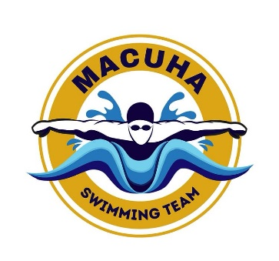
3rd MACUHA SWIMMING CHAMPIONSHIP

CLASS A B C D / AGE GROUP

Event No | Age Group | Distance | Stroke | Event No.
BOYS |  |  |  | GIRLS
1 | 11 and over | 200 meters | Freestyle | 2
3 | 10 and under | 100 meters | Freestyle | 4
5 | 10 and under | 4x50 meter | Medley Relay | 6
7 | 11 and over | 4x50 meter | Medley Relay | 8
9 | 11 and over | 50 meters | Butterfly | 10
11 | 10 and under | 50 meters | Butterfly | 12
13 | 11 and over | 50 meters | Backstroke | 14
15 | 10 and under | 50 meters | Backstroke | 16
17 | 11 and over | 200 meters | Individual Medley | 18
19 | 10 and under | 200 meters | Individual Medley | 20
21 | 11 and over | 50 meters | Breaststroke | 22
23 | 10 and under | 50 meters | Breaststroke | 24
25 | 11 and over | 50 meters | Freestyle | 26
27 | 10 and under | 50 meters | Freestyle | 28
29 | 10 and under | 4x50 meter | Freestyle Relay | 30
31 | 11 and over | 4x50 meter | Freestyle Relay | 32

